Latitude and Longitude Assignment 2
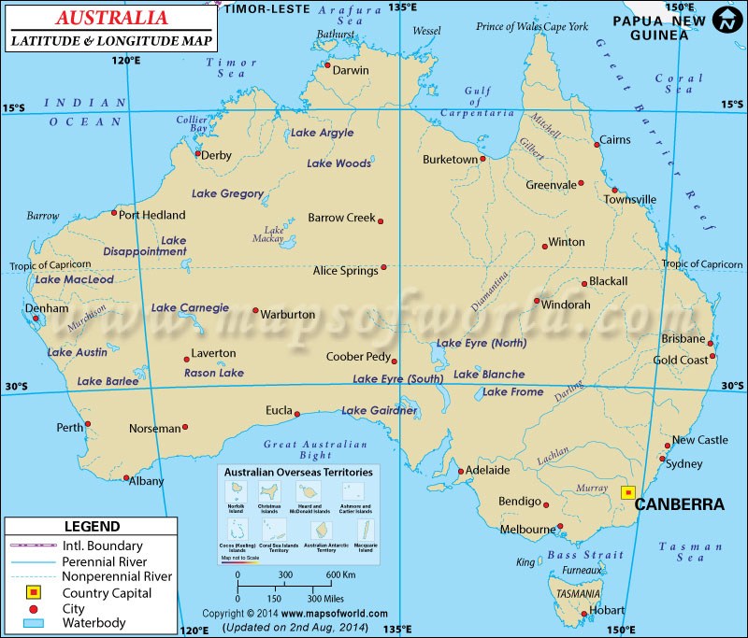

Please list the coordinates (latitude and longitude of the following cities:

Denham
Laverton
Norseman
Hobart
Blackall
Cairns
Darwin
Barrow Creek
Port Hedland
Bendingo
Adelaide
Coober Pedy

