Latitude and Longitude Assignment

Instructions
Please complete the following assignment. You may work with a partner. Please round your latitude and longitude measurements to the nearest tenth. For ex, 27.865 degrees N would be rounded to 27.9 degrees N. This assignment will be due Friday March 24th.

- What direction do lines of Latitude run?

- What direction do lines of Longitude run?

- Lines of Latitude are measured in degrees ____________or ___________ (directions) while lines of longitude are measured in degrees ____________ or__________ (directions).
- The baseline for lines of latitude is the ____________________

- The baseline for lines of longitude is the ____________________

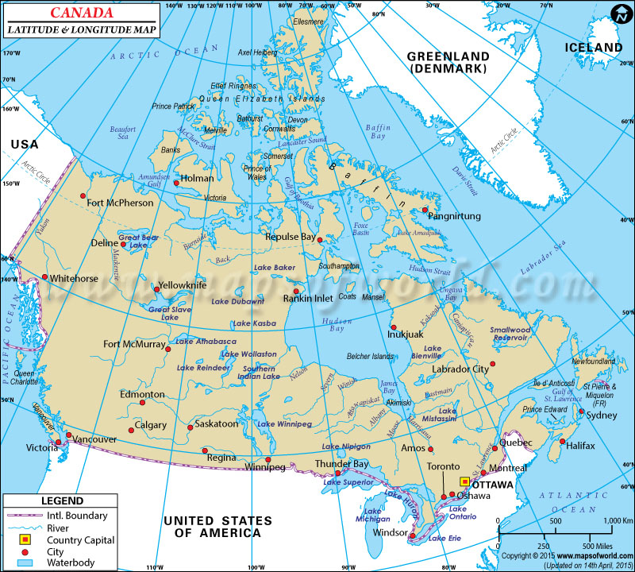

- Please estimate the latitude and longitude of the these cities using the map above

Fort McMurray ________________________________________________________________
Thunder Bay __________________________________________________________________
Victoria ______________________________________________________________________
Windsor______________________________________________________________________
Halifax _______________________________________________________________________
Labrador City __________________________________________________________________
Holman_______________________________________________________________________
Ottawa________________________________________________________________________
- Please label the following cities on the map provided on the following page. You may simply locate them with a “dot” and a label, or you may make a legend.

- Please label the equator and prime meridian
- Vancouver Canada --- 49.2827° N, 123.1207° W
- Moscow Russia--- 55.7558° N, 37.6173° E
- Chicago USA ---41.8781° N, 87.6298° W
- Sydney Australia ---33.8688° S, 151.2093° E
- Cairo Egypt ---30.0444° N, 31.2357° E
- Beijing China ---39.9042° N, 116.4074° E
- Paris France ---48.8566° N, 2.3522° E
- Tokyo Japan ---35.6762° N, 139.6503° E
- Cape Town South Africa--- 33.9249° S, 18.4241° E
- Sao Paulo Brazil--- 23.5558° S, 46.6396° W
