Astronomy Test Review

- What is the name of the line of longitude that measures 0 degrees?

- What is the name of the line of latitude that measures 0 degrees?

- Explain why when its summer in Winnipeg Canada, its winter in Sydney Australia.

- The geocentric view can be described as

- Theory that the earth orbits around the sun
- Theory that the earth orbits around the moon
- Theory that the sun orbits around Jupiter
- Theory that the sun orbits around the earth

- The heliocentric view can be described as

- Theory that the earth orbits around the sun
- Theory that the earth orbits around the moon
- Theory that the earth orbits around Jupiter
- Theory that the sun orbits around the sun

- An elliptic orbit is an orbit that is in what shape?

- Circle
- Square
- Oval
- Linear

- What is the name given to the two days of the year when we have equal amounts of daytime and nighttime?

- Solstice
- Equinox
- Earth day
- Harvest moon

- What is the Earths tilt?

- 98 degrees
- 50 degrees
- 14.5 degrees
- 23.5 degrees
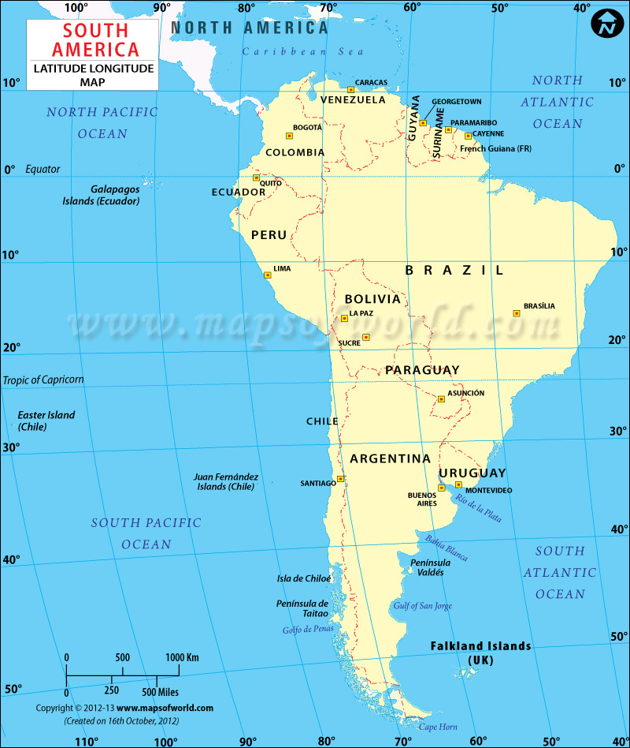

Please use the above image to answer the following five questions.

- What are the coordinates of Santiago Chile?

- 19 degrees S, 65 degrees W
- 16 degrees S, 47 degrees W
- 34 degrees S, 71 degrees W
- 10 degrees S, 66 degrees W
- 0 degrees, 77 degrees W

- What are the coordinates of Quito Ecuador?

- 19 degrees S, 65 degrees W
- 16 degrees S, 47 degrees W
- 34 degrees S, 71 degrees W
- 10 degrees S, 66 degrees W
- 0 degrees, 77 degrees W

- What are the coordinates of Brasilia Brazil?

- 19 degrees S, 65 degrees W
- 16 degrees S, 47 degrees W
- 34 degrees S, 71 degrees W
- 10 degrees S, 66 degrees W
- 0 degrees, 77 degrees W

- What are the coordinates of Caracas Venezuela?

- 19 degrees S, 65 degrees W
- 16 degrees S, 47 degrees W
- 34 degrees S, 71 degrees W
- 10 degrees S, 66 degrees W
- 0 degrees, 77 degrees W

- What are the coordinates of Sucre Bolivia?

- 19 degrees S, 65 degrees W
- 16 degrees S, 47 degrees W
- 34 degrees S, 71 degrees W
- 10 degrees S, 66 degrees W
- 0 degrees, 77 degrees W

- Please label the 8 phases of the moon. Note that the dark moon on the right is the “new moon”
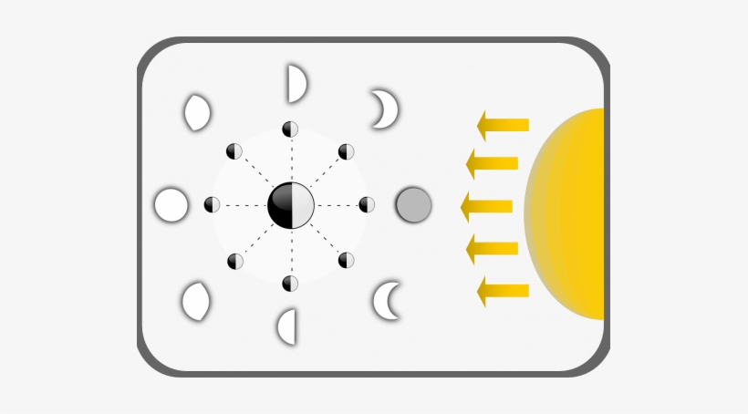

- How long is the lunar cycle?

- One week
- One year
- One month
- One day

- The term “waxing” refers to when the moon is

- Becoming larger (visually)
- Becoming smaller (visually)
- Getting hotter
- Getting colder

- The term “waning” refers to when the moon is

- Becoming larger (visually)
- Becoming smaller (visually)
- Getting hotter
- Getting colder

- Scientists are predicting that in England next week the earth will pass perfectly in between the sun and the moon, casting a shadow on the moon. What is this called?

- Lunar eclipse
- Solar eclipse
- Solar solstice
- Lunar solstice

- What star is the last star on the Little Dipper constellation?

- Orion
- Europa
- Ursa Major
- Polaris (north star)

- Why is the north star always pointing north

- The south pole points directly at it
- The north pole points directly at it
- It lines up perfectly with the equator all year round
- It sits directly over Selkirk

- The unit of measure we use measure the distance between galaxies is

- Kilometers
- Light years
- Feet
- Astronomical Units

- The unit of measure we use to measure the distance between planets in our solar system

- Kilometers
- Light years
- Feet
- Astronomical Units

- How many kilometers is one Astronomical Unit?

- 150
- 100 million
- 150 million
- 100 billion

- Define a light year

- 4.0 AUs is equal to how many km?

- 45 million km
- 600 million km
- 765 million km
- 1380 million km

- 10.2 AUs is equal to how many km?

- 45 million km
- 480 million km
- 765 million km
- 1,530 million km

- 1.5 AUs is equal to how many km?

- 225 million km
- 480 million km
- 765 million km
- 1380 million km

- 750 million km is equal to how many AUs?

- 5 AU
- 7 AU
- 5.8 AU
- 3.33 AU

- 120 million km is equal to how many AUs?

- 0.8 AU
- 7 AU
- 5.8 AU
- 3.33 AU

- 500 million km is equal to how many AUs?

- 0.8 AU
- 7 AU
- 5.8 AU
- 3.33 AU

- The four terrestrial planets are

- Mars, Jupiter, Earth and Mercury
- Earth, Pluto, Mars and Venus
- Earth, Mercury, Venus and Mars
- Jupiter, Saturn, Neptune and Uranus

- The Sun’s mass mostly consists of which two elements?

- Hydrogen and Helium
- Hydrogen and Neon
- Helium and Neon
- Iron and Hydrogen

- The four Jovial planets are

- Mars, Jupiter, Earth and Mercury
- Earth, Pluto, Mars and Venus
- Earth, Mercury, Venus and Mars
- Jupiter, Saturn, Neptune and Uranus

- List the 8 planets in order starting with Mercury.

- What do planets need to orbit around to be considered a planet?

- Another planet
- A Moon
- A Star
- An Asteroid

- Why is Venus considered Earth’s twin planet?

- List 3 characteristics that the four terrestrial planets share

- What is the main reason Venus is our hottest planet?

- It is the closest planet to the sun
- It has a thick atmosphere full of carbon dioxide
- It has no atmosphere
- It is the largest planet

- What is the largest planet in our solar system?

- What is the smallest planet in our solar system?

- What is the only planet in the solar system that can sustain life?

- What are 3 characteristics that all 4 Jovial planets share?

- What planet has a red spot which is a giant storm that’s been active for over 400 years?

- Saturn
- Earth
- Venus
- Jupiter

- Which planet has an axis tilted to 98 degrees?

- Earth
- Mars
- Neptune
- Uranus
- Please compare Meteoroids, Meteors and Meteorites. What makes them each different?

- What two forces work together to keep objects in orbit?

- Gravity and Inertia
- Gravity and Nuclear Fusion
- Friction and Centripetal force
- Pressure and Nuclear Fusion

- Where are most of our solar system’s asteroids found?

- Oort cloud
- Asteroid belt
- Orbiting Jupiter
- Orbiting Pluto

- What was theorized to have impacted the earth 65 million years ago, causing the extinction of dinosaurs.

- Meteorite
- Comet
- Impact with another Mars size planet
- Asteroid

- What is the main difference between a planet and a dwarf planet?

- Which of the following is considered a dwarf planet

- Jupiter
- The moon
- Europa
- Pluto

- A shooting star is another name for a

- Meteor
- Asteroid
- Comet
- Meteoroid

- Comets are primarily made up of

- Dust
- Ice
- Rock
- All of the above

- How do we know that Halley’s comet orbits the sun approximately every 76 years?

- We have a GPS tracker on it
- Humans have recorded its occurrence for hundreds of years
- Based on its mass
- Based on its composition

- What is a Stellar Nebula made up of?

- During nuclear fusion, what element fuses together to produce helium?

- In billions of years, the sun will die off and turn into a

- Red Super Giant
- Black Hole
- White Dwarf
- Neutron Star

- Which element can be made in our sun?

- Gold
- Lithium
- Tin
- Silver

- Why are we unable to see a blackhole? Please Explain

- What are the names of the two different object that may form at the end of a massive star’s life cycle?

- Although Saturn and Jupiter contain much of same material that the sun contains, nuclear fusion does not occur. Why is this?

- Neutron stars have such a high pressure that _____________ and ____________ merge together forming Neutrons.

- Hydrogen and helium
- Protons and electrons
- Electrons and plasma
- Carbon and phosphorus

