Astronomy Quiz Review

Please complete the following review questions. Your quiz will consist of 20 of these exact multiple-choice questions as well as a moon phase labelling diagram.

- Please label all 8 phases of the following moon cycle.

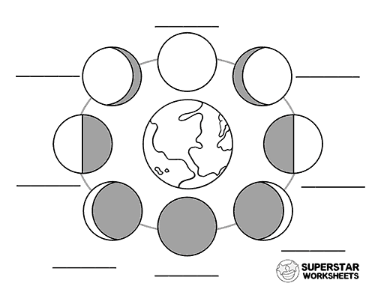

- What is the name of the longest day of the year?
- Spring equinox
- Summer equinox
- Summer solstice
- Winter solstice

- What is the name given to the two days of the year when we have equal amounts of daytime and night time?

- Solstice
- Equinox
- Earth day
- Harvest moon

- What is the Earths tilt?

- 98 degrees
- 50 degrees
- 14.5 degrees
- 23.5 degrees

- What is the main cause of our seasons?

- The earth’s tilt
- The spherical shape
- its elliptic orbit
- the moons gravitational pull

- Earth’s slightly elliptic orbit causes which of the following to occur?
- Our seasons to be so varying in temperature
- Summer to be slightly longer in the northern hemisphere
- Winter to be slightly longer in the northern hemisphere
- Earth to always be the same distance from the sun

- 0 degrees latitude is ______________ and 0 degrees longitude is_____________

- Prime meridian, equator
- Equator, prime meridian
- Tropic of cancer, tropic of Capricorn
- Equator, North Pole

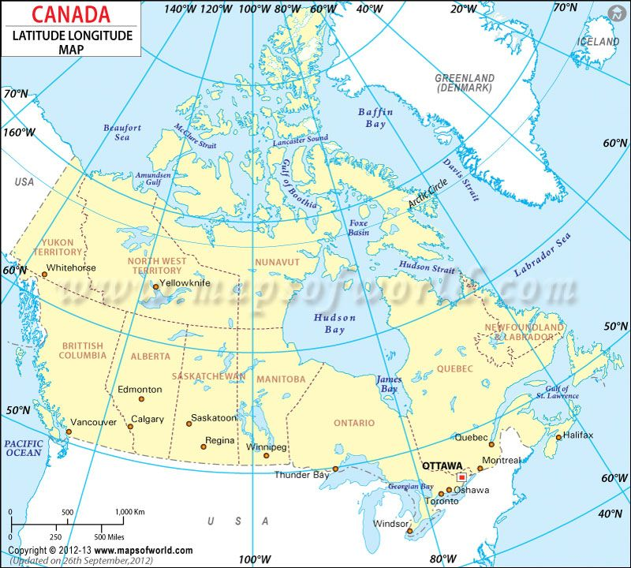

Please use the above map to answer questions 8-12

- What are the coordinates (latitude and longitude) of Saskatoon?

- 53 degrees N, 109 degrees W
- 47 degrees N, 65 degrees W
- 46.5 degrees N, 63 degrees W
- 64 degrees N, 118 degrees W
- 62 degrees N, 137 degrees W

- What are the coordinates (latitude and longitude) of Yellowknife?

- 53 degrees N, 109 degrees W
- 47 degrees N, 65 degrees W
- 46.5 degrees N, 63 degrees W
- 64 degrees N, 118 degrees W
- 62 degrees N, 137 degrees W

- What are the coordinates (latitude and longitude) of Ottawa?

- 53 degrees N, 109 degrees W
- 47 degrees N, 75 degrees W
- 46.5 degrees N, 63 degrees W
- 64 degrees N, 118 degrees W
- 62 degrees N, 137 degrees W

- What are the coordinates (latitude and longitude) of Whitehorse?

- 53 degrees N, 109 degrees W
- 47 degrees N, 65 degrees W
- 46.5 degrees N, 63 degrees W
- 64 degrees N, 118 degrees W
- 62 degrees N, 137 degrees W

- What are the coordinates (latitude and longitude) of Halifax?

- 53 degrees N, 109 degrees W
- 47 degrees N, 65 degrees W
- 46.5 degrees N, 63 degrees W
- 64 degrees N, 118 degrees W
- 62 degrees N, 137 degrees W

- While we are having our summer solstice on June 21st this year, They will be celebrating ________________ in Australia.

- Winter Solstice
- Spring equinox
- Fall Equinox
- Winter Equinox

- The geocentric view can be described as

- Theory that the earth orbits around the sun
- Theory that the earth orbits around the moon
- Theory that the sun orbits around Jupiter
- Theory that the sun orbits around the earth

- The heliocentric view can be described as
- Theory that the earth orbits around the sun
- Theory that the earth orbits around the moon
- Theory that the earth orbits around Jupiter
- Theory that the sun orbits around the sun

- An elliptic orbit is an orbit that is in what shape?

- Circle
- Square
- Oval
- Linear

- Moons can be defined as celestial objects that orbit

- The sun
- Galaxies
- Other moons
- Planets

- Why does the moon appear to be the brightest object in our sky?

- Because of how close it is to earth
- It produces the most heat
- It produces the most light
- It is the largest object in our night sky

- What celestial object is the reason we have high tides and low tides?

- Space station
- Moon
- Sun
- Mars

- The moons spins on its axis at the same rate at which it orbits the earth. What is this called?

- Asynchronous Rotation
- Synchronous Rotation
- Perfect orbit
- 0 rotation

- How long is the lunar cycle?
- One week
- One year
- One month
- One day

- The term “waxing” refers to when the moon is

- Becoming larger (visually)
- Becoming smaller (visually)
- Getting hotter
- Getting colder

- The term “waning” refers to when the moon is

- Becoming larger (visually)
- Becoming smaller (visually)
- Getting hotter
- Getting colder

- Scientists are predicting that in Australia next week the moon will pass perfectly in front of the sun, casting a shadow on it. What is this called?

- Lunar eclipse
- Solar eclipse
- Solar solstice
- Lunar solstice

- Which Planet has the most moons?

- Earth
- Jupiter
- Uranus
- Saturn

- The last two stars of what constellation point towards the north star?

- Big dipper
- Little dipper
- Pleiades
- Polaris

- Why is the north star always pointing north

- The south pole points directly at it
- The north pole points directly at it
- It lines up perfectly with the equator all year round
- It sits directly over Winnipeg

- Why does the sun rise in the east and set in the west

- The earth spins towards the west
- The earth spins towards the north
- The earth spins towards the east
- The earth spins towards the south

- What Unit is used to measure distances within our solar system?

- Light years
- Parsecs
- Meters
- Astronomical Units (AU)

- What unit is used to measure distance outside our solar system?

- Light years
- Kilometers
- Meters
- Astronomical Units (AU)

- How many kilometers is one Astronomical Unit?

- 150
- 100 million
- 150 million
- 100 billion

- What is a light year measuring?

- Time
- Distance
- Velocity
- Brightness

- 3.6 AUs is equal to how many km?

- 45 million km
- 540 million km
- 765 million km
- 1380 million km

- 9.2 AUs is equal to how many km?

- 45 million km
- 480 million km
- 765 million km
- 1380 million km

- 5.1 AUs is equal to how many km?

- 45 million km
- 480 million km
- 765 million km
- 1380 million km

- 0.3 AUs is equal to how many km?

- 45 million km
- 480 million km
- 765 million km
- 1380 million km

- 500 million km is equal to how many AUs?

- 0.8 AU
- 7 AU
- 5.8 AU
- 3.33 AU

- 870 million km is equal to how many AUs?

- 0.8 AU
- 7 AU
- 5.8 AU
- 3.33 AU

- 120 million km is equal to how many AUs?

- 0.8 AU
- 7 AU
- 5.8 AU
- 3.33 AU

- 1050 million km is equal to how many AUs?

- 0.8 AU
- 7 AU
- 5.8 AU
- 3.33 AU

